NOVA Information Management School
Master in Data Science and Advanced Analytics
Predicting Online Shopper Purchase Intent
(An End-to-End MLOps System)

Course: Machine Learning Operations (MLOps)

Group Members
[Your Name] – [Student Number]
[Member 2] – [Number]

Contents
1 Introduction 1
2 Project planning 1
3 Methodology 2
3.1 Data quality and the feature store 2
3.2 Cleaning, splitting, and leakage control 2
3.3 Model selection, training, and tracking 2
3.4 Testing 2
4 Evaluation and explainability 3
4.1 Data exploration 3
4.2 Model performance 3
4.3 Explainability with SHAP 3
4.4 Data drift monitoring 4
5 Serving and production readiness 5
6 Creative extensions 5
6.1 Optuna hyperparameter search 5
6.2 Kubernetes deployment with autoscaling 6
7 Conclusion 6
References 7
Appendix A: Package versions 7

1 Introduction
E-commerce conversion is rare and expensive to influence. In the Online Shoppers Purchasing Intention dataset [1] (UCI, 12,330 sessions), only 15.5% of sessions end in a purchase. A retailer that can predict, during a live session, whether a visitor intends to buy can act on it with a targeted discount, retargeting spend, or live-chat prompt, so the model has a clear owner and a measurable cost of error. This project simulates the full process of deploying and operating such a model: data validation, a feature store, experiment tracking with versioning, explainability, containerised serving, drift monitoring, and automated tests, delivered as a modular, reproducible pipeline.
The 17 features per session divide into browsing behaviour (counts and durations of administrative, informational, and product pages), engagement quality (BounceRates, ExitRates, and PageValues, the average value of pages seen before a transaction), and context (Month, VisitorType, SpecialDay, Weekend). The target is the binary Revenue flag.
The central difficulty is class imbalance: predicting “no purchase” for every session is 84.5% accurate and useless, so accuracy is rejected as the headline metric. Model selection optimises ROC-AUC, which is threshold-independent and stable under imbalance, while the business-facing metric is buyer-class recall, because the costly error is failing to flag a buyer and missing an intervention. A success criterion was fixed before any modelling: ROC-AUC at least 0.90 and buyer recall at least 0.70, both met (Section 4.2). The engineering target was equally explicit: every component is a separately runnable Kedro pipeline, the system reproduces identical results from a pinned environment, and each of the brief’s six requirements is met by a verifiable artifact. Two extensions, Optuna search and a Kubernetes deployment with autoscaling, go beyond that surface (Section 6).

2 Project planning
The work ran as seven short agile sprints, sequenced by dependency rather than requirement number so each sprint produces a verified artifact the next one needs. Data quality and the feature store come first, since nothing downstream is trustworthy without them; modelling and tracking follow; serving, drift, and tests come last, because they presuppose a working model.
Table 1: Sprint plan, effort estimate, and outcome.
Sprint | Focus | Outcome
0 | Scaffold, raw data, EDA | Kedro project; data in 01_raw; EDA notebook
1 | Data quality, feature store | GX gate (8 expectations); local parquet store
2 | Clean, split, select, train | MLflow tracking and registry; SHAP
3 | Serving, containers | FastAPI service in a Docker image
4 | Data drift | Evidently seasonal drift report
5 | Tests, orchestration | 24 tests; pipelines runnable in isolation
6 | Report, extensions | This report; Optuna and Kubernetes

Each sprint ran the same loop: implement, verify, test, commit, which surfaced integration faults early. Sprint 5 exposed that the MLflow-registry model could not be loaded standalone, fixed by exporting a portable on-disk copy while the pipeline was still fresh. Two scope decisions followed the reproducibility constraint: the cloud feature store (Hopsworks) was deferred for a local parquet store so the project runs offline for any grader, and Spark was kept out of scope for a single-machine proof of concept, with its place in a scaled deployment costed in Section 5. Extensions were scheduled last, after the nine required pipelines and the report, so they could only raise the ceiling and never threaten the reproducible core.

3 Methodology
The system is nine modular Kedro pipelines on the Kedro data-layer convention. Each runs on its own with kedro run --pipeline=<name> or as one chain, and every dataset passes through the Kedro catalog, so no node carries a hardcoded path. That modularity is what lets the system be graded component by component and reproduced as a whole.

3.1 Data quality and the feature store
Raw data is not trusted implicitly. The data_quality pipeline defines a Great Expectations suite of eight expectations covering column presence, the buyer-ratio sanity range, value bounds on the rate features, and the closed value sets for Month and VisitorType. A gate node halts the pipeline on any violation, so bad data fails fast rather than corrupting a model silently. Validated features are written by data_feat_engineering and feature_store into a local parquet feature store of three groups (numerical, categorical, target). A hard cloud dependency would break the reproducibility the brief requires; the local store still satisfies feature versioning while keeping the project offline, and the cloud path is documented as optional. Feature engineering runs per row, before the split, so it cannot leak; it adds is_holiday_season, total_pages, total_duration, avg_duration_per_page, has_page_value, and product_depth_bin, all motivated by Section 4.1.

3.2 Cleaning, splitting, and leakage control
Data_cleaning one-hot encodes Month and VisitorType and casts booleans to integers, giving a 33-feature model-input table. data_split makes a stratified 80/20 split at a fixed seed, holding the 15.5% buyer ratio in both folds. Leakage is controlled structurally: per-row transforms are safe before the split, and the only learned transform, feature scaling, is wrapped inside a scikit-learn Pipeline with the classifier, so the scaler is fitted on the training fold alone. The test set stays sealed, cross-validation on the training set is the validation mechanism, and the held-out set is evaluated exactly once (Section 4.2). Bundling the scaler inside the model also removes training-serving skew, because the serving layer cannot forget to scale when scaling is part of the model.

3.3 Model selection, training, and tracking
Model_selection compares Logistic Regression, Random Forest, and Gradient Boosting by 5-fold stratified cross-validated ROC-AUC on the training set only. Imbalance is handled with class_weight='balanced' rather than synthetic oversampling, keeping the procedure deterministic. The pipeline returns only the champion’s name and configuration, not a fitted model, so model_train can do the final fit with a train-only scaler and preserve the leakage control of Section 3.2. model_train fits the champion, evaluates it once on the sealed test set, and records parameters, metrics, and the model to MLflow through kedro-mlflow autolog. The champion is registered as online_shoppers_champion and each re-run creates a new version automatically; the registry reached version 5 across development runs, demonstrating the versioning requirement. A second, portable copy of the model, a plain directory with no absolute paths, is what the serving and batch-inference layers load, which makes the model runnable in a container or a fresh clone (Section 5).

3.4 Testing
A test suite of 24 pytest cases guards the pipeline: data-contract assertions on the Great Expectations gate, unit tests on the feature-engineering and cleaning node logic, and integration tests confirming each pipeline runs in isolation through the catalog. The suite is what makes the modular-run and reproducibility claims checkable rather than asserted.

4 Evaluation and explainability

4.1 Data exploration
Two findings from the exploratory analysis (notebook 01_eda.ipynb) shaped the modelling and appear in Figure 1. Conversion is strongly seasonal: the buyer rate climbs from 1.6% in February to 25.4% in November against a 15.5% average, a recurring shift that later becomes the basis of the drift study (Section 4.4) rather than synthetic noise. PageValues separates the classes cleanly: buyers average 27.26 against 1.98 for non-buyers, a 14-fold gap that makes it the strongest single predictor and foreshadows the SHAP ranking (Section 4.3). New visitors also convert higher, at 24.9% against 13.9% for returning visitors.
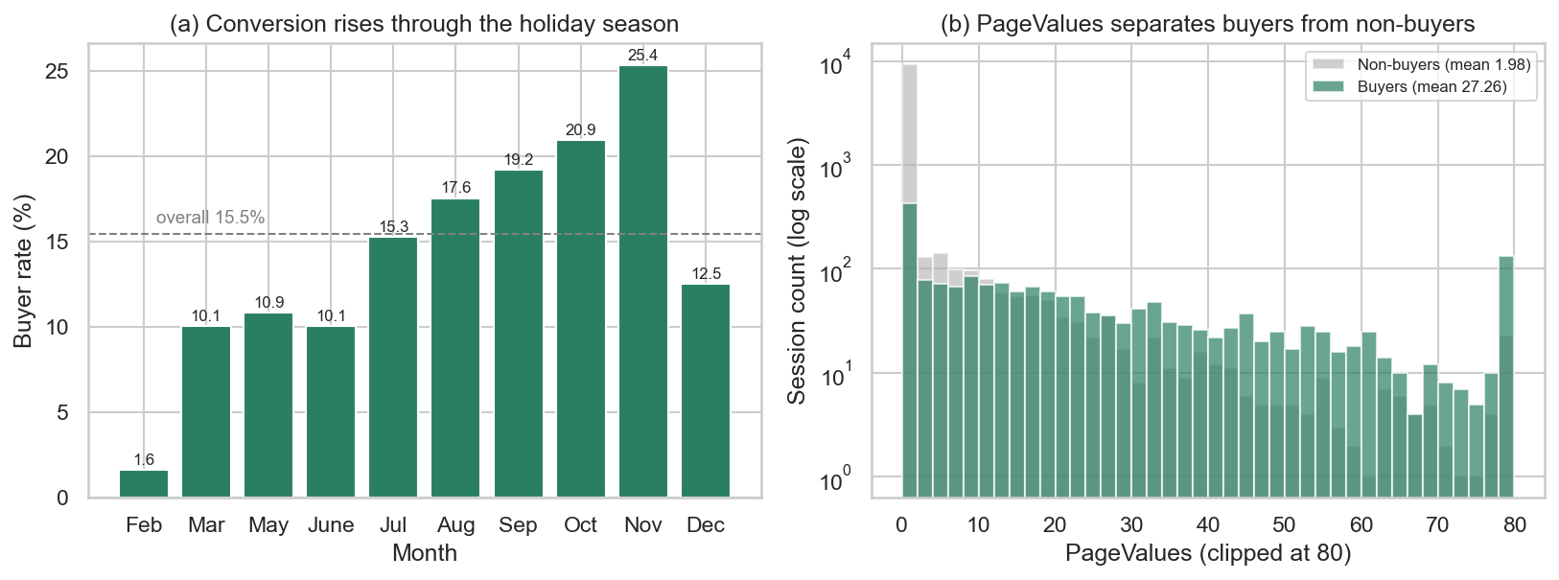
Figure 1: EDA overview. (a) Buyer rate by month rises from 1.6% (February) to 25.4% (November), the seasonal swing that motivates the drift study. (b) PageValues distribution by outcome (log count): buyers sit far to the right of non-buyers, confirming it as the dominant predictor.

4.2 Model performance
Table 2 reports the cross-validated selection; Random Forest and Gradient Boosting are close, and Random Forest is chosen on the marginally higher CV ROC-AUC (a 0.0007 gap, within noise, so the choice is effectively a tie resolved in favour of the more robust ensemble). Table 3 gives the champion’s held-out performance, computed once on the sealed 20% test set.
Table 2: Cross-validated model selection (5-fold stratified ROC-AUC, training set only).
Candidate | CV ROC-AUC
Logistic Regression | 0.9086
Gradient Boosting | 0.9309
Random Forest (champion) | 0.9316

Table 3: Champion (Random Forest) test-set performance.
Metric | Value
ROC-AUC | 0.927
Recall (buyers) | 0.730
Precision (buyers) | 0.612
F1 (buyers) | 0.666
Accuracy | 0.886

The test ROC-AUC of 0.927 sits within 0.005 of the cross-validated 0.9316, indicating no overfitting: the model generalises to unseen sessions about as well as it did in cross-validation. Both pre-registered targets are met, with the model recovering 73% of true buyers against a 15.5% base rate at a precision usable for a low-cost intervention. The choice of recall over accuracy is vindicated here, since an accuracy-optimised model would have suppressed the very minority class the task exists to find.

4.3 Explainability with SHAP
A model a business cannot interpret is one it will not act on. model_train produces a SHAP summary plot (Figure 2) using TreeExplainer [3], chosen by model family for a roughly thousand-fold speed-up over the model-agnostic permutation explainer. SHAP ranks PageValues first, consistent with its 14-fold buyer separation from Section 4.1. The engineered features earn their place: has_page_value ranks second and the seasonal features rank highly, direct evidence that the feature engineering of Section 3.1 added real predictive signal rather than noise.
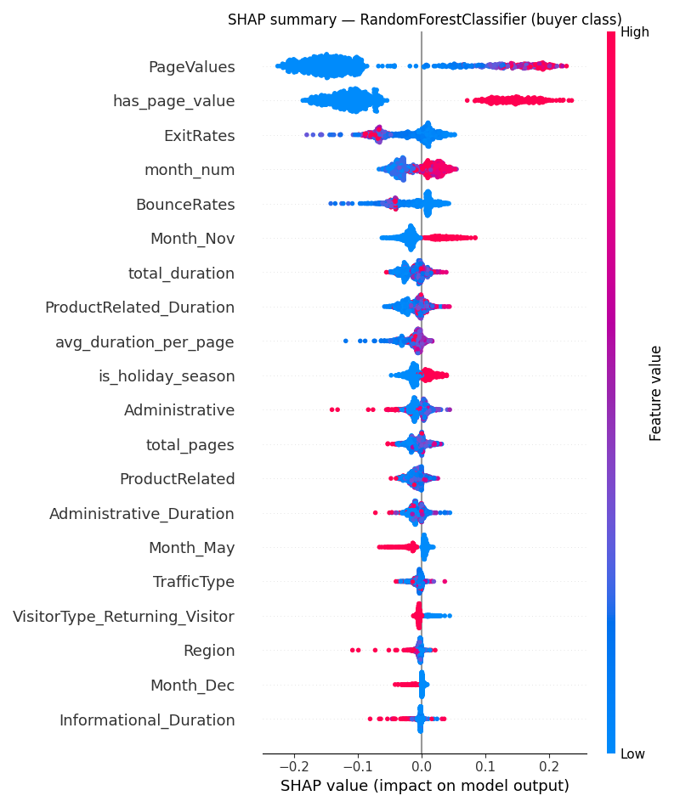
Figure 2: SHAP summary plot for the champion (buyer class). Horizontal position is each feature’s contribution to buyer probability. PageValues dominates, with the engineered has_page_value and the seasonal features next.

4.4 Data drift monitoring
A model trained across all months degrades silently if the live traffic mix shifts. Rather than inject synthetic noise, the data_drift pipeline uses the dataset’s own seasonality as a genuine drift scenario: an Evidently DataDriftPreset compares a low-season reference batch (is_holiday_season == 0) against the holiday-rush current batch (is_holiday_season == 1). The per-column report flags 10 of 22 feature columns drifted, a drift share of 0.455. The largest shifts are in SpecialDay (0.41 normalised Wasserstein distance), in browsing depth and duration (ProductRelated, total_pages, total_duration), and, most consequentially, in PageValues (0.11). Because PageValues is the model’s most important feature (Section 4.3), this is a clear case of silent degradation: the seasonal distribution diverges exactly where the model is most sensitive. The pipeline emits a visual HTML report (Figure 3) and a machine-readable CSV, so the check is ready to drive an automated retraining trigger (Section 7).
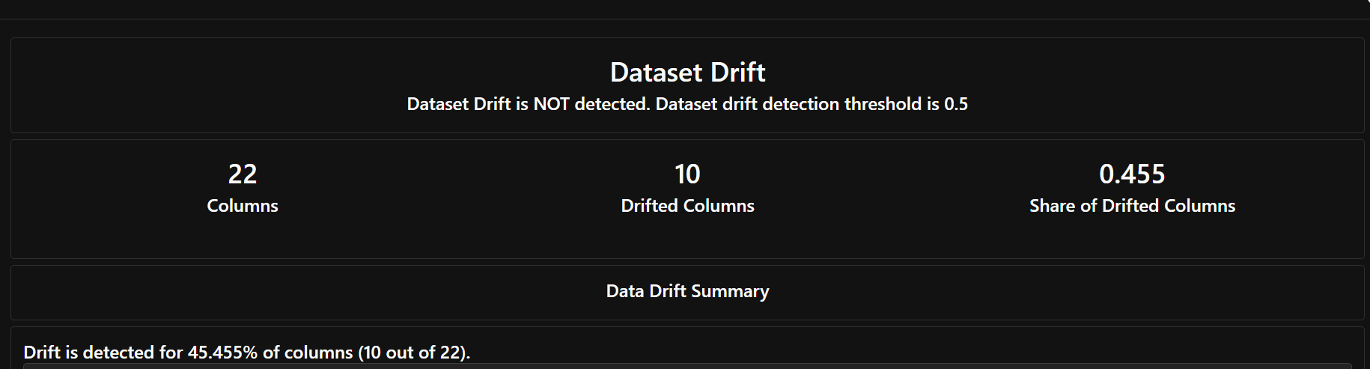
Figure 3: Evidently report comparing the low-season reference and the holiday-rush batch, with the drifted columns flagged.

5 Serving and production readiness
The champion is served by a FastAPI application exposing /predict, /health for liveness, and /ready for readiness, the last returning the 33-column feature schema. It loads the portable model directory of Section 3.3, so the same artifact runs identically in a clone or a container. The model_predict pipeline and the API share one feature contract, so training and serving cannot diverge. The service ships as a non-root python:3.12-slim Docker image with a HEALTHCHECK, verified end to end: /health returns 200, /ready returns the schema, /predict matches the pipeline, and an unknown feature column returns HTTP 422.
As a proof of concept, several shortcuts were taken deliberately to keep it reproducible. Table 4 lists the main risks, the mitigation, and a rough effort to close each in a real deployment.
Table 4: Production risks, mitigations, and estimated effort to productionise.
Risk | Mitigation | Effort
Pandas will not scale past single-machine memory | Kedro catalog abstracts I/O, so swapping pandas.ParquetDataset for spark.SparkDataset is a config change, not a rewrite | +2–3 wk
Seasonal drift degrades accuracy silently (§4.4) | The data_drift CSV becomes a scheduled retraining trigger | +1–2 wk
No live monitoring of prediction quality | MLflow-logged production metrics plus a dashboard; the surface already exists | +1 wk
Training-serving skew | One shared feature schema plus the scaler bundled inside the model | by design

6 Creative extensions
Both extensions are isolated and optional: the nine required pipelines run identically with or without them, so reproducibility is never compromised.

6.1 Optuna hyperparameter search
The required path fixes the champion’s hyperparameters; the model_optimisation pipeline tunes them with Optuna’s TPE sampler [2], a Bayesian search more sample-efficient than grid search, over 30 seeded trials, optimising the same training-set CV ROC-AUC so the reported gain carries no leakage. The tuned configuration is n_estimators=400, max_depth=14, min_samples_leaf=7, max_features=sqrt, lifting CV ROC-AUC from 0.9316 to 0.9347.
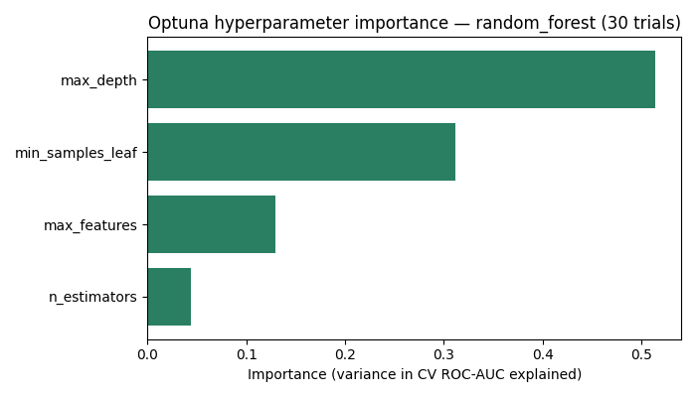
Figure 4: Optuna hyperparameter importance for the champion. Tree depth (0.51) dominates, ahead of min_samples_leaf (0.31), max_features (0.13), and n_estimators (0.04).
The gain is real but small, at +0.0031 ROC-AUC. The honest reading is that the binding constraint is signal saturation, not hyperparameters: a Random Forest with sensible defaults already captures most of the structure PageValues exposes, so tuning refines rather than transforms the model. The importance ranking is the durable result, with tree depth governing the capacity to combine PageValues with secondary features. The tuned configuration plugs into model_train unchanged.

6.2 Kubernetes deployment with autoscaling
The Docker image alone satisfies the serving requirement; Kubernetes adds replication, health-gated traffic, and elastic capacity. Three manifests in serving/k8s/ define a Deployment of two replicas with liveness and readiness probes and CPU requests, a NodePort Service load-balancing across them, and a HorizontalPodAutoscaler scaling from 2 to 6 replicas at a 60% average-CPU target, motivated by the seasonal spikes the drift study reveals. It was validated live on Docker Desktop: both pods reached Ready, the Service served /predict through NodePort 30080 (buyer probability about 0.32), and with a metrics-server installed the HPA reported real CPU usage at 5% against the 60% target, confirming the autoscaling loop was active (evidence in serving/k8s/deployment_evidence.txt).

7 Conclusion
This project delivers an end-to-end MLOps system meeting all six requirements with separately runnable, reproducible components. The Random Forest champion reaches a test ROC-AUC of 0.927 and recovers 73% of true buyers, meeting both pre-registered targets with no overfitting, and SHAP confirms PageValues as the dominant driver with the engineered features adding real signal. The seasonal drift study flags 10 of 22 features drifting between seasons, including the most important one, making silent degradation concrete. The model is served behind FastAPI and Docker and deployed live to Kubernetes with working CPU autoscaling, while Optuna search produced a small gain that, read honestly, points to signal saturation rather than a tuning deficit.
Several limitations remain. The model is trained on one static dataset with a single random seed, which precludes confidence intervals on the headline metrics. The drift study compares two seasonal slices of the same historical data rather than a true future batch, so it demonstrates the detection mechanism rather than a live shift. The feature store is local parquet, where a multi-team setting would want a shared versioned store, and the Kubernetes autoscaling was checked under low synthetic load rather than a real spike. Future work follows directly: wire the drift CSV into an automated retraining trigger, load-test the autoscaler to observe a real scale-up, migrate feature I/O to Spark to test the scaling mitigation in practice, and calibrate the decision threshold to the retailer’s intervention cost.

References
[1] C. O. Sakar, S. O. Polat, M. Katircioglu, and Y. Kastro, “Real-time prediction of online shoppers’ purchasing intention using multilayer perceptron and LSTM recurrent neural networks,” Neural Computing and Applications, vol. 31, no. 10, pp. 6893–6908, 2019. Dataset: UCI Machine Learning Repository.
[2] T. Akiba, S. Sano, T. Yanase, T. Ohta, and M. Koyama, “Optuna: A next-generation hyperparameter optimization framework,” in Proc. 25th ACM SIGKDD Int. Conf. on Knowledge Discovery and Data Mining, 2019, pp. 2623–2631.
[3] S. M. Lundberg and S.-I. Lee, “A unified approach to interpreting model predictions,” in Advances in Neural Information Processing Systems, vol. 30, 2017.

Appendix A: Package versions
Reproduce with uv pip install -r requirements.txt && kedro run. A clean-environment install was verified to reproduce results exactly; for example model_predict scores 2,466 test rows and predicts 456 buyers. The nine pipelines and their roles are catalogued in the repository README.
Package | Version | Package | Version
kedro | 1.3.1 | shap | 0.52.0
kedro-mlflow | 2.0.2 | evidently | 0.7.21
mlflow | 3.11.1 | great-expectations | 1.16.1
scikit-learn | 1.5.2 | optuna | 4.8.0
pandas | 2.3.3 | fastapi | 0.136.0
numpy | 2.3.5 | uvicorn | 0.44.0

